
[Type here]

VOIP lab experiment#3 Setting up the extensions in FreePBX

Installation and Repair of Telecommunications Equipment

Name of student:
Group Number:
Date:

[Type here]
The purpose of the lab is to demonstrate the ability of the students to configure the PBX by creating different extensions.

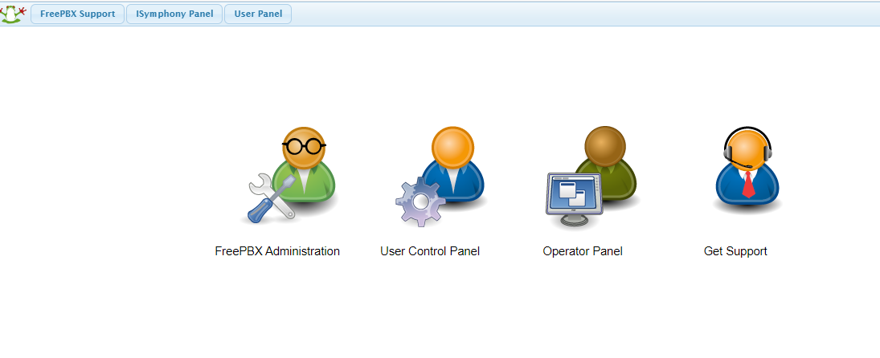
Click FreePBX Administration
Username: admin Password: admin

[Type here]
- This will allow to access your PBX, Elastix. In the main page click on PBX
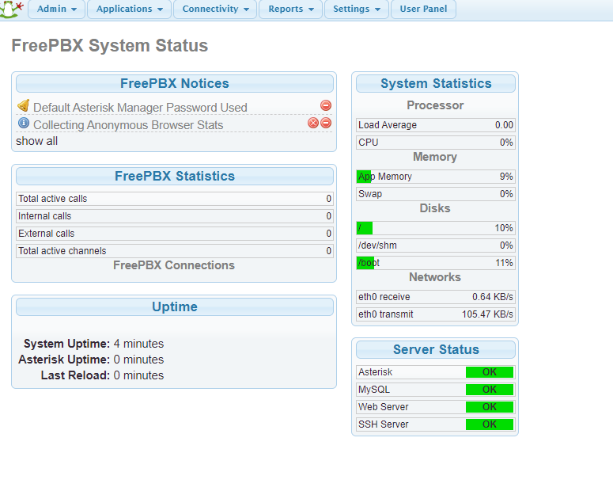

[Type here]
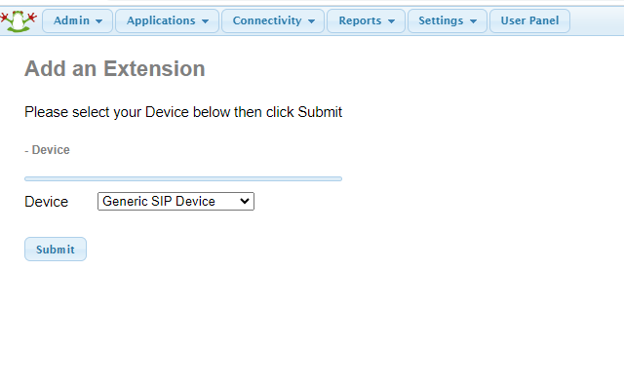
Click on Applications then extensions
- In device, choose: generic SIP device, then click on submit

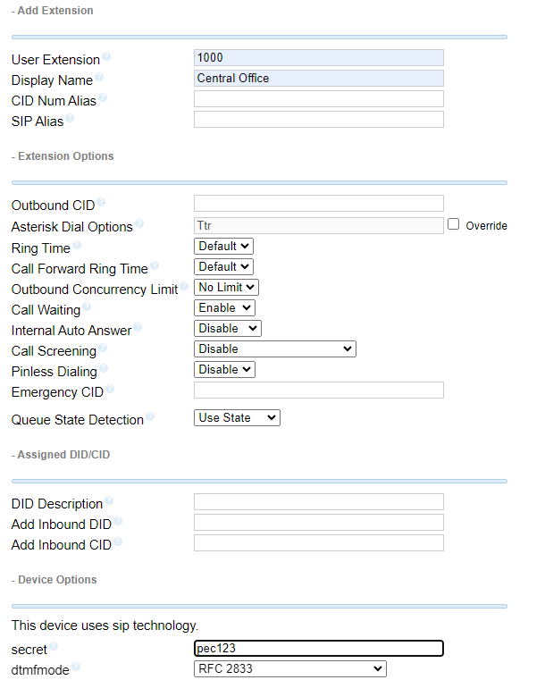


- Create the following information to create the first extension: User extension: 1000
[Type here]
Display Name: Main Office
Secret: pec123


[Type here]
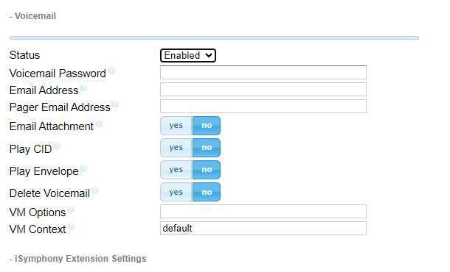
- Enable the voiceMail
- Go to the end of the page and click on “submit”
******You have to click on “apply config” in order to finalize the extension. If you do not, the extension will not be created*****


- The extension is now created as you can see on the right side of the screen. Create the 2 following extension as well by repeating the steps 2-4:

User extension | Display Name | Secret
2000 | xxxx | pec123
3000 | Boss | pec123

